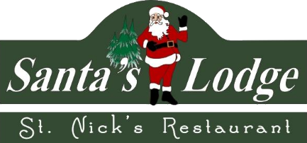
Welcome to Santa’s Lodge and St. Nick’s Restaurant, where we are committed to the safety of our guests and employees! We are excited to be welcoming you back into our hotel and restaurant, and we want you to be aware of the changes we have made in response to the COVID-19 pandemic. We are closely following guidelines from the CDC and our government to ensure you have a safe experience while visiting.

The following procedures are being implemented at Santa’s Lodge:
- Employee Requirements: All employees will be required to perform temperature checks upon arrival for their shift. They will be required to stay home if they are experiencing any type of symptoms or are running a fever. They will be obligated to wear facial masks, use proper hand-washing procedures, and follow frequent sanitizing protocols throughout the building.
- Check-in Procedures: We encourage you to call our front desk once you arrive so we can take final payment if necessary for any remaining balance, check you in over the phone, and leave your keys on the counter for you to pick up. We are not currently having guests sign registration cards to minimize contact between our guests and staff. We also have 6-foot markers on the floor at the front desk should you need to speak with a front desk attendant and hand sanitizer will be available. Our attendants will remain a safe distance from you behind the counter.
- Pool Use Protocols: We are asking all pool patrons to utilize social distancing protocols by remaining at least 6 feet apart from other guests. Please use provided hand sanitizer as needed and bring towels from your hotel room to use in the pool area. Pool towels will not be provided at this time. Pool doors, handles, loungers, and chairs will be cleaned and sanitized frequently.
- Stayover Treatment: We will not be treating stayover rooms to assure no employees enter your room once you take possession until after your departure. Should you need assistance or new linens while staying, please call the front desk and we will be sure to leave the items requested outside your door.
- Check-out Procedures: Guests are encouraged to call the front desk upon departure and leave their keys in their room rather than visiting the front desk to check out. All keys will be sanitized before reuse, and all rooms will be thoroughly deep cleaned with germicidal cleaner between rentals.

The following procedures are being implemented at St. Nick’s Restaurant:
- Employee Requirements: All employees will be required to perform temperature checks upon arrival for their shift. They will be required to stay home if they are experiencing any type of symptoms or are running a fever. They will be obligated to wear facial masks and gloves, use proper hand-washing procedures, and follow frequent sanitizing protocols throughout the restaurant.
- Tables and Menus: We are limiting our occupancy and have rearranged our tables to assure each is at least 6 feet apart. We have instituted the use of disposable paper menus that will be discarded after every use. We also have 6-foot markers on the floor near the register and hand sanitizer will be available.
- Cleaning Procedures: Employees will be cleaning and sanitizing tables and chairs after each use. Floors, restrooms, and all other common areas and surfaces will be sanitized multiple times a day. We have removed all table-top commonly touched items and will provide individual portions of condiments as requested with your meal.

Our guests and employees are our top priority and we are committed to assuring a safe and healthy visit. Thank you for choosing Santa’s Lodge and St. Nick’s Restaurant!

